实验十五 SQLServer2008管理事务和锁
实验步骤：

一、环境准备
需求描述：某学校要求学生把校园卡与银行卡绑定，学生数据库STUDENT中有两张表，其中校园卡号是学生的学号。
Icbc_card(studentcardid,icbcid,balance)
Campus_card(stuentcardid,balance)

1.首先创建数据库：
create database [student] on primary
(name = N'student',FILENAME = N'E:\sql_data\student1.mdf', size=3072KB,
MAXSIZE = UNLIMITED,FILEGROWTH=1024KB )
LOG ON
(name = N'student_log',FILENAME = N'E:\sql_data\student_log1.ldf', size=1024KB,
MAXSIZE = 2048GB,FILEGROWTH=10% )
GO

2.创建表
create table campus_card
(
studentcardid char(8),
balance decimal(10,2)
);
create table icbc_card
(
studentcardid char(8),
icbcid char(10),
balance decimal(10,2)
);
3.截图：
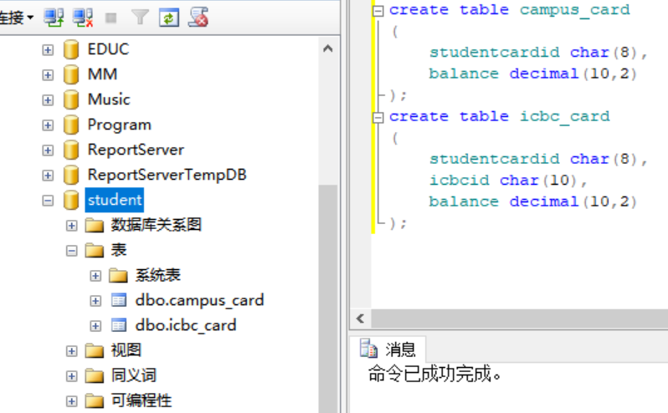
- 插入数据
代码：
insert INTO campus_card values ('20150031',30);
insert INTO campus_card values ('20150032',50);
insert INTO campus_card values ('20150033',70);

insert INTO icbc_card values ('20150031','2015003101',1000);
insert INTO icbc_card values ('20150032','2015003201',1000);
insert INTO icbc_card values ('20150033','2015003301',1000);
截图：
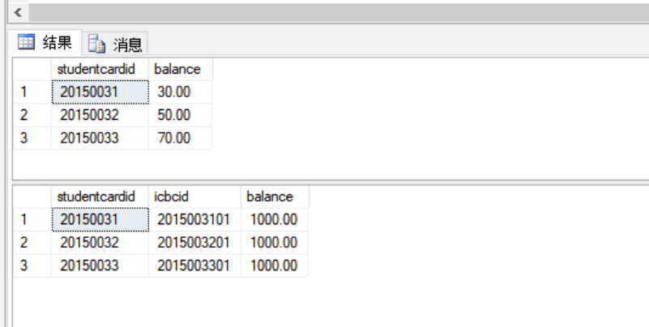

二、针对数据库STUDENT，完成以下内容。
- 编写一个事务处理实现如下操作，学号为20150032的学生需要从银行卡转账两百元到自己的校园卡中，若过程中出现错误则回滚。
代码：
set transaction isolation level repeatable read
Begin transaction
use student
go

declare @x decimal(10,2)
select @x=balance
from icbc_card
where studentcardid='20150032'
set @x=@x-200
if(@x>=0)
begin
update icbc_card set balance =@x where studentcardid='20150032'
update campus_card set balance=balance+200
where studentcardid='20150032'
commit tran
end
else
begin
print'余额不足，不能转账'
rollback tran
end
运行截图：

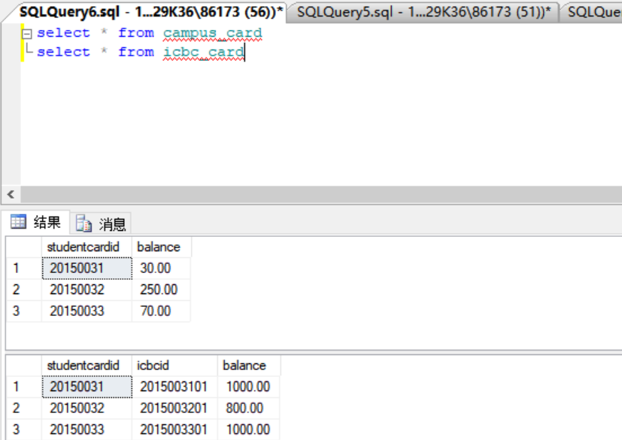

- 基于当前数据库STUDENT，涉及样例展示四种数据不一致的问题，丢失修改，读脏数据，不可重复读和幻读(删除和插入).
- 丢失修改
事件一：
Begin tran
declare @balance decimal(10,2)
select @balance=balance from campus_card where studentcardid='20150033'
waitfor delay '00:00:05'
set @balance=@balance-10
update campus_card set @balance=@balance where studentcardid='20150033'
commit tran
go
select balance from campus_card where studentcardid='20150033'
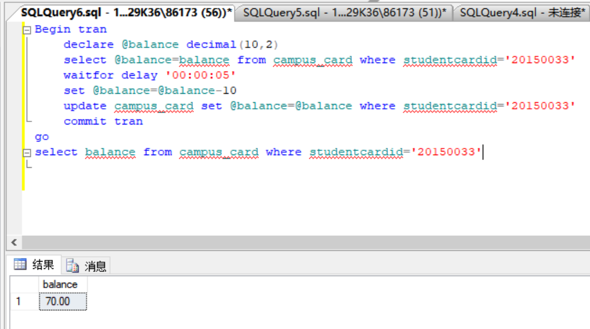

事件二：
Begin tran
declare @balance1 decimal(10,2)
select @balance1=balance from campus_card where studentcardid='20150033'
waitfor delay '00:00:05'
set @balance1=@balance1-20
update campus_card set balance=@balance1 where studentcardid='20150033'
commit tran
go
select balance from campus_card where studentcardid='20150033'

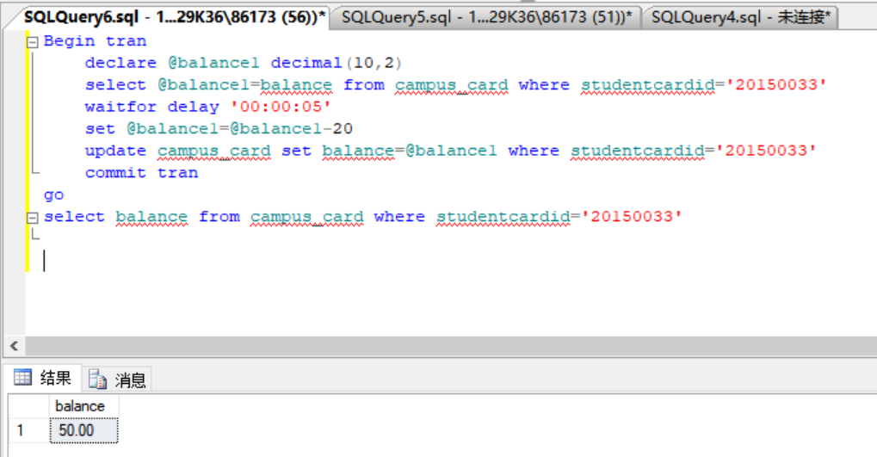

- 读脏数据
事件一：
set transaction isolation level read uncommitted
begin tran
declare @balance decimal(10,2)
select @balance=balance from campus_card where studentcardid='20150032'
update campus_card set balance=@balance+100 where studentcardid='20150032'
waitfor delay '00:00:05'
rollback tran
go
select balance from campus_card where studentcardid='20150032'
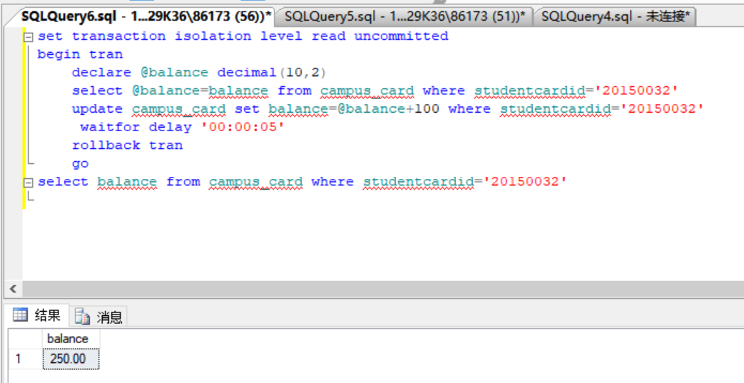

事件二：
set transaction isolation level read uncommitted
begin tran
declare @balance decimal(10,2)
select @balance=balance from campus_card where studentcardid='20150032'
update campus_card set balance=@balance+50 where studentcardid='20150032'
waitfor delay '00:00:05'
rollback tran
go
select balance from campus_card where studentcardid='20150032'

- 不可重复读
事件一：
set transaction isolation level read uncommitted
use student
go
begin tran
select balance from campus_card where studentcardid='20150031'
waitfor delay '00:00:10'
select balance from campus_card where studentcardid='20150031'
commit tran

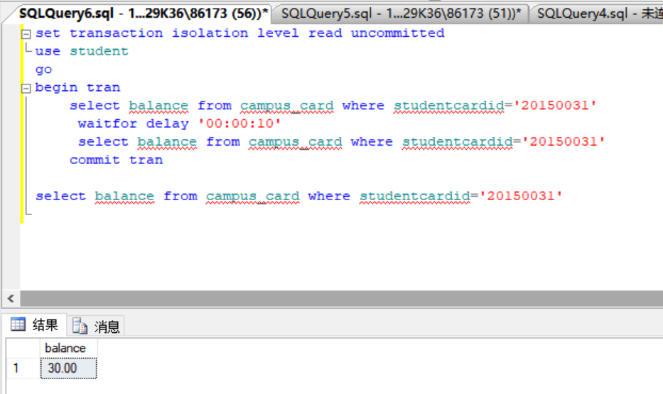

事件二：
set transaction isolation level read uncommitted
use student
go
begin tran
update campus_card set balance=balance+200
where studentcardid='20150031'
commit tran
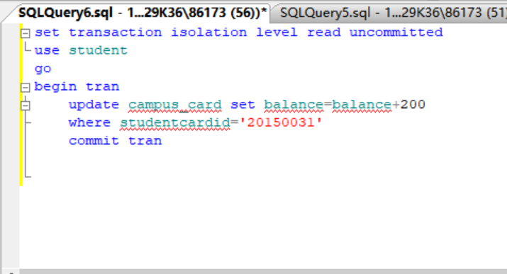
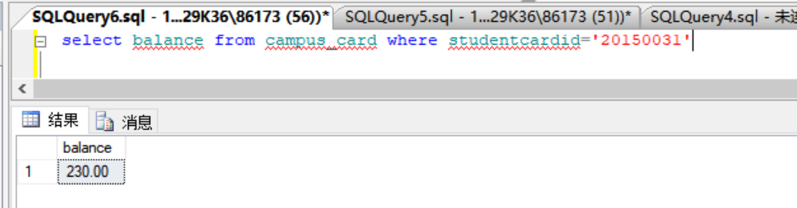

事件一读取了数据，事件二更改了数据，事件一再读取数据，事件一两次读取的都不同。

- 幻读
-------插入
事件一：
set transaction isolation level read uncommitted
begin tran
use student
go
select balance from campus_card where studentcardid='20150031'
waitfor delay '00:00:05'
select balance from campus_card where studentcardid='20150031'
commit tran
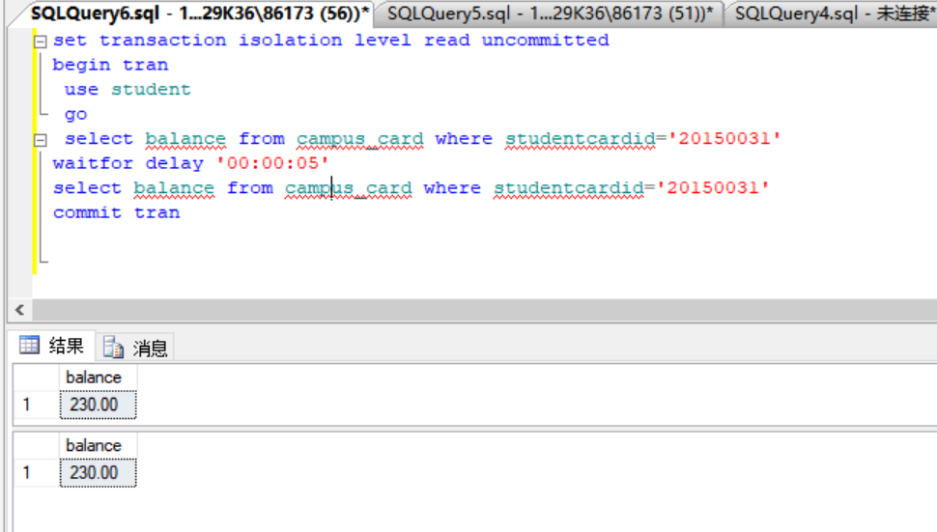

事件二：
set transaction isolation level serializable
begin tran
insert into campus_card values ('20150031',30)
commit tran

select balance from campus_card where studentcardid='20150031'

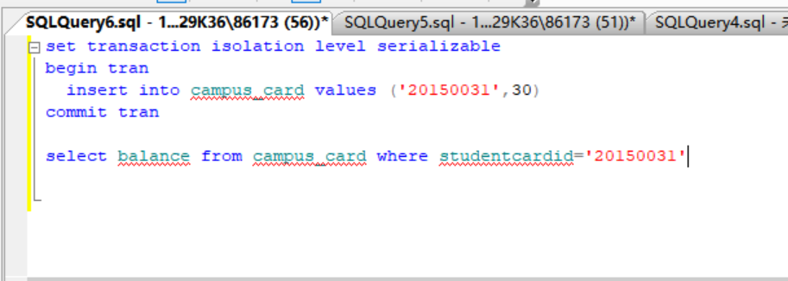

------删除
事件一：
set transaction isolation level read uncommitted
begin tran
use student
go
select balance from campus_card where studentcardid='20150031'
waitfor delay '00:00:05'
select balance from campus_card where studentcardid='20150031'
commit tran

事件二：
set transaction isolation level repeatable read
begin tran
delete from campus_card where studentcardid='20150031'
select balance from campus_card where studentcardid='20150031'
commit tran
